Relationship Between a response and a REST API

🔹 What Is the Relationship Between a Response and a REST API?
# Source: Chatgpt (GPT-5-Mini) at [1/16/2026]
A REST API (Representational State Transfer API) defines how a server should respond to client requests in a structured, predictable way. The response is the server’s answer to a client’s request made through the REST API.

✅ Relationship Explained:
# Source: Chatgpt (GPT-5-Mini) at [1/16/2026]
Concept | Explanation
Response | The message the server sends back after processing a client’s request. It contains a status code, headers, and usually a body with data or confirmation.
REST API | The set of rules that define how the server formats and sends that response to make communication consistent and meaningful.
The response is how the REST API communicates results of requests back to the client.

✅ What a REST API Response Typically Includes:
# Source: Chatgpt (GPT-5-Mini) at [1/16/2026]
Component | Purpose | Example
Status Code | Indicates success or failure | 200 OK, 404 Not Found
Headers | Metadata about the response | Content-Type: application/json
Body | Data or message returned | JSON object representing a user, error message, or confirmation

✅ Example of a REST API Response:
# Source: Chatgpt (GPT-5-Mini) at [1/16/2026]
If a client sends a request to get user data:
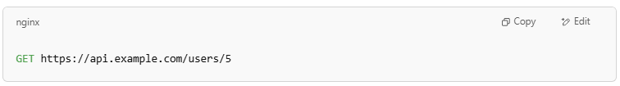
GET https://api.example.com/users/5

The server might respond with:
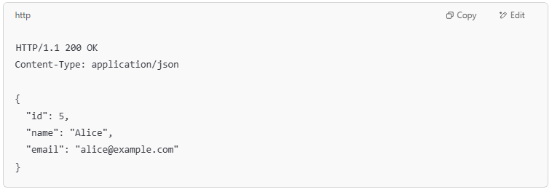
HTTP/1.1 200 OK
Content-Type: application/json

{
"id": 5,
"name": "Alice",
"email": "alice@example.com"
}

🧠 Key Point:
# Source: Chatgpt (GPT-5-Mini) at [1/16/2026]
A response is the REST API’s way of delivering the result of the client’s request, following standardized formats so clients can easily understand and process the data or status.

✅ Summary:
# Source: Chatgpt (GPT-5-Mini) at [1/16/2026]
- The response is the server’s reply in the REST API communication.
- REST API defines the format and meaning of the response (status codes, JSON data, etc.).
- Together, requests and responses form the full interaction in a RESTful system.
Want me to show you how to handle REST API responses in code?

